**LOW LIGHT IMAGE ENHANCEMENT**

**ASSIGNMENT 2**

**Introduction**

In many real-world scenarios, images captured in low light or nighttime conditions often suffer from poor visibility, making it difficult to discern important details. This problem is especially prevalent in critical fields such as autonomous driving, where clear and accurate visual data is crucial for decision-making. Object detection in low-light conditions is crucial for various applications, including recognizing pedestrians, vehicles, and animals in autonomous driving systems or identifying intruders in surveillance footage. By employing **semantic segmentation**, different object categories are color-coded for easy identification. These advancements help create more accurate and reliable systems that can effectively operate in challenging visual environments, ensuring safety and efficiency in critical applications.

**Abstract**

Low light and night vision image augmentation aims to enhance images captured in environments with minimal to no visible light. In such conditions, details are often obscured due to noise, blurriness, and low contrast, making the images difficult to interpret. However, by employing advanced image enhancement techniques, these photographs can be transformed into clearer and more recognizable images. The techniques used for this enhancement are histogram equalization, CLAHE (Contrast Limited Adaptive Histogram Equalization), bilateral filtering, gamma correction, and unsharp masking.

These image enhancement methods are essential for improving the clarity of images in critical applications like autonomous driving, security, and surveillance, where accurate and detailed visual information is crucial for decision-making. Additionally, semantic segmentation is employed for object detection, with different categories of objects color-coded for easier identification. By combining image enhancement with object detection techniques, this approach significantly improves the quality and interpretability of low-light images, allowing for more accurate analysis and reliable outcomes in challenging conditions.

**Link to dataset**

<https://drive.google.com/file/d/1MLeLUf8H4CqvWUoSn5TePqRWznueWvig/view?usp=sharing>

**Pipeline of techniques applied for image enhancement**

*Original Low-Light Image → Histogram Equalization → Contrast Limited Adaptive Histogram Equalization (CLAHE) → Bilateral Filter → Gamma Correction → Unsharp Masking*

**Object Detection**

Object detection analyzes complex images that contain a mixed multitude of objects, at different distances and locations, amidst varying, often visually noisy backgrounds. Objects can appear anywhere within the visual frame, be near or far, and can overlap with each other.

**Object Detection on Output images using Semantic Segmentation**

Besides locating objects in images, analysis of the images at pixel level is useful and widely used to solve many real-world problems, especially in areas such as self-driving, biomedical diagnosis, and so on. Image semantic segmentation is one of the techniques to understand an image at pixel level. Specifically, it attempts to partition the image into semantically meaningful parts, and to classify each part into one of the predefined classes.

**Packages Used**

**# Install required packages and setup display**

**!pip install torch torchvision**

**torch:**

This is the core library for **PyTorch**, a powerful deep learning framework developed by Facebook’s AI Research lab. PyTorch is widely used for building and training deep neural networks due to its flexibility and ease of use. It provides tools for creating and optimizing machine learning models, handling tensor computations, and working with GPUs for accelerated training.

**torchvision:**

This library is an extension of PyTorch specifically for computer vision. It includes popular datasets (like CIFAR-10, COCO), model architectures (such as ResNet, VGG), and image transformations. It’s commonly used alongside torch for image-based tasks such as object detection, image classification, and segmentation.

### Parametric Values in the Code

1. **Confidence Threshold (0.5):**
   * This value filters out weak detections. By setting a threshold of 0.5, you ensure that only objects with a confidence score greater than 50% are considered. The choice of 0.5 is a balance between detecting as many objects as possible and maintaining detection reliability.
   * **Reason:** This is a standard practice in object detection models, as it provides a good trade-off between detection recall and precision.
2. **Target Classes:**
   * The target_classes dictionary defines which object classes the system will focus on. For example, classes like "person," "car," "dog," etc., are specifically chosen because they are of interest in autonomous driving and surveillance applications.
   * **Reason:** These classes are defined based on the use case. For example, in autonomous driving, detecting pedestrians (humans) and vehicles (cars, trucks) is crucial, and animals may also be important depending on the scenario.
3. **Mask Threshold (0.5):**
   * The masks generated for object segmentation are thresholded at a 0.5 value, meaning a pixel is considered part of an object if the mask value is greater than 0.5.
   * **Reason:** This helps to clean up noisy or fuzzy segmentation results by only considering areas that are strongly indicative of the object, which is particularly important in low-light conditions.

### Mask R-CNN for Object Detection and Segmentation in Low-Light Conditions

Mask R-CNN (Mask Region-based Convolutional Neural Network) is an advanced deep learning model that extends Faster R-CNN to perform instance segmentation, simultaneously detecting objects and segmenting them at the pixel level. This capability makes Mask R-CNN particularly valuable in scenarios where precise object localization and identification are crucial, such as in autonomous driving and surveillance, especially under challenging conditions like low-light environments.

In the context of this project, Mask R-CNN plays a critical role in object detection and semantic segmentation after the application of image enhancement techniques to address low-visibility scenarios, such as those encountered in night time or poor lighting conditions. The model is designed to handle multi-class object detection, which includes the identification of humans, vehicles, and animals in the enhanced images.

### Key Features of Mask R-CNN in This Project

1. **Object Detection and Segmentation:**
   * Mask R-CNN is used to detect objects (e.g., vehicles, pedestrians, animals) in an image and generate segmentation masks for each instance of the detected objects. This provides more detailed information than traditional bounding box-based object detection.
   * In this project, Mask R-CNN is tasked with identifying and segmenting objects in the images after they have been processed through various image enhancement techniques like histogram equalization, CLAHE, and bilateral filtering. These enhancements are designed to improve the visibility of objects in low-light conditions.
2. **Enhanced Night Vision Integration:**
   * The primary challenge in this project is detecting and segmenting objects in images captured under low-light conditions. To tackle this, an array of night vision enhancement techniques (e.g., histogram equalization, CLAHE, and bilateral filtering) is applied to the input images, which helps improve object visibility and contrast.
   * Once the image is enhanced, Mask R-CNN is applied to perform both semantic segmentation (classifying each pixel of the image into a predefined object class) and instance segmentation (distinguishing between different objects of the same class, e.g., two different vehicles).
3. **Multi-Class Object Detection:**
   * The Mask R-CNN model is trained to detect and segment multiple object classes such as person, bicycle, car, bus, dog, and cat. These classes are particularly relevant for autonomous driving and surveillance systems, where identifying different types of objects in the environment is essential for safe navigation and decision-making.

**Output Images**

The detected objects are humans, animals and vehicles. The humans are denoted in green colour and vehicles in blue colour .

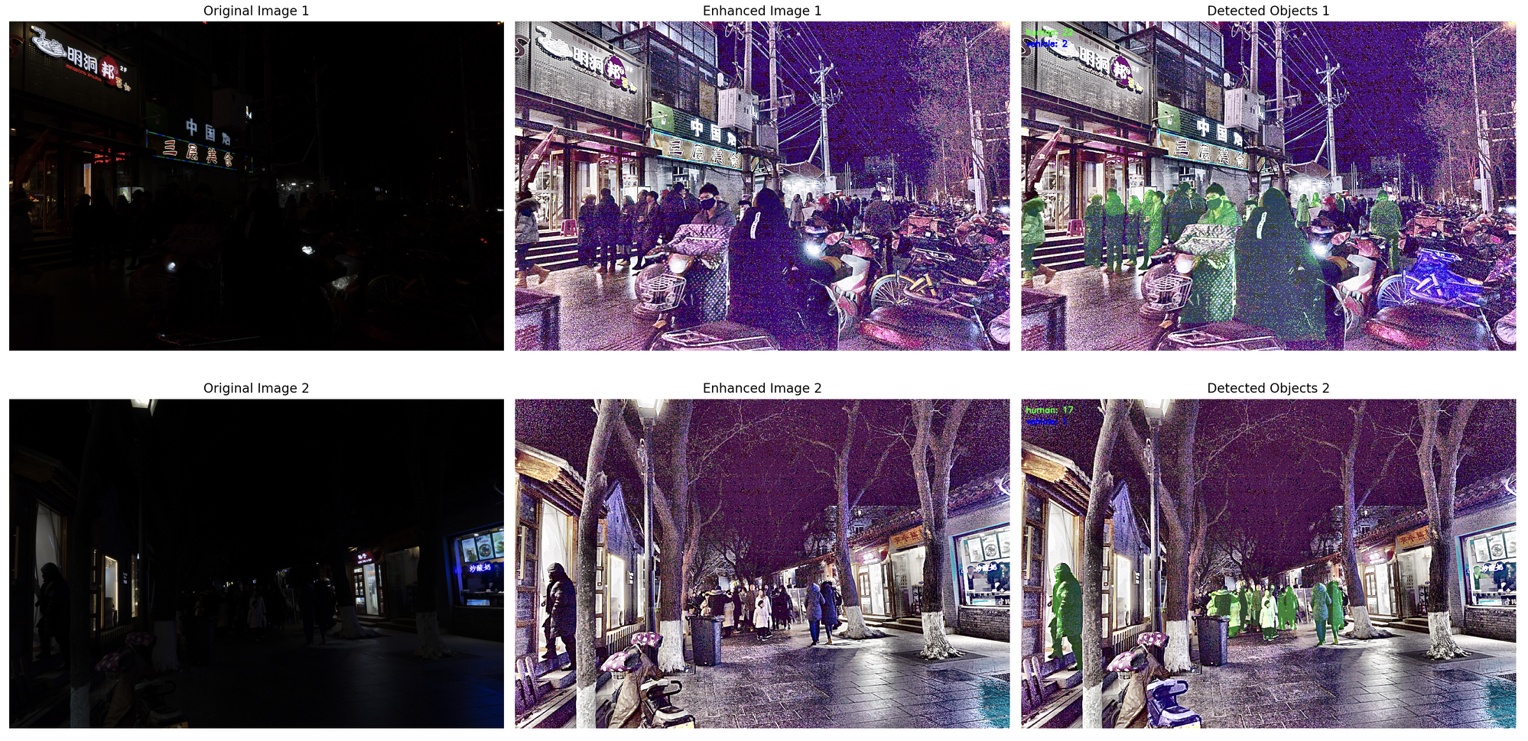

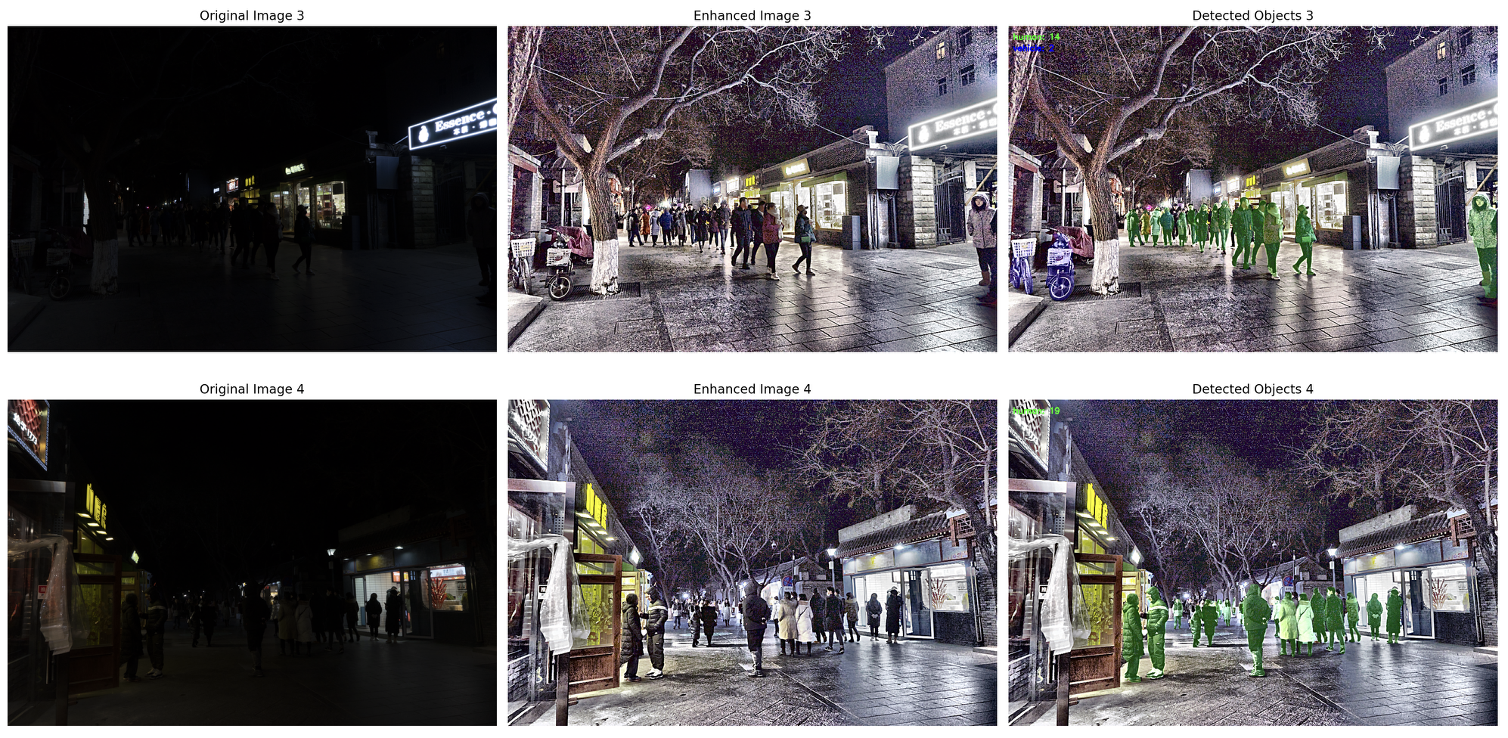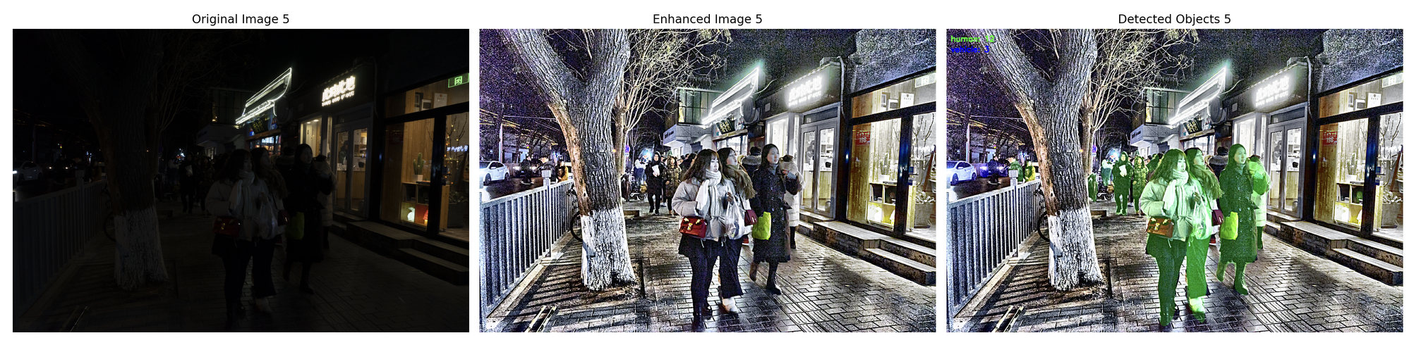

The code was then modified such that other than detected objects (foreground) , everything else was turned to ‘yellow’ colour, in order to distinguish it as the background of the image. We have also increased the opacity of the detected objects.

**Code**

import cv2

import numpy as np

import matplotlib.pyplot as plt

import torch

import torchvision

import logging

# Configure logging

logging.basicConfig(level=logging.INFO, format='%(asctime)s - %(levelname)s - %(message)s')

logger = logging.getLogger(__name__)

class IntegratedNightVisionSystem:

def __init__(self):

"""Initialize the detection system"""

logger.info("Loading detection model...")

try:

self.model = torchvision.models.detection.maskrcnn_resnet50_fpn(pretrained=True)

self.model.eval()

if torch.cuda.is_available():

self.model = self.model.cuda()

logger.info("Using GPU for inference")

else:

logger.info("Using CPU for inference")

except Exception as e:

logger.error(f"Error loading model: {str(e)}")

raise

# Define target classes and their categories

self.target_classes = {

1: {'name': 'person', 'category': 'human'},

2: {'name': 'bicycle', 'category': 'vehicle'},

3: {'name': 'car', 'category': 'vehicle'},

4: {'name': 'motorcycle', 'category': 'vehicle'},

6: {'name': 'bus', 'category': 'vehicle'},

8: {'name': 'truck', 'category': 'vehicle'},

17: {'name': 'dog', 'category': 'animal'},

18: {'name': 'cat', 'category': 'animal'},

19: {'name': 'horse', 'category': 'animal'},

20: {'name': 'sheep', 'category': 'animal'},

21: {'name': 'cow', 'category': 'animal'}

}

# Colors for different categories

self.category_colors = {

'human': (0, 255, 0), # Green for humans

'animal': (0, 0, 255), # Red for animals

'vehicle': (255, 0, 0) # Blue for vehicles

}

def enhance_image(self, image):

"""Enhanced night vision processing"""

try:

# Histogram equalization for each channel

r_channel, g_channel, b_channel = cv2.split(image)

r_eq = cv2.equalizeHist(r_channel)

g_eq = cv2.equalizeHist(g_channel)

b_eq = cv2.equalizeHist(b_channel)

hist_eq_image = cv2.merge((r_eq, g_eq, b_eq))

# CLAHE enhancement in LAB color space

lab = cv2.cvtColor(hist_eq_image, cv2.COLOR_BGR2LAB)

l_channel, a_channel, b_channel = cv2.split(lab)

clahe = cv2.createCLAHE(clipLimit=10.0, tileGridSize=(10, 10))

l_channel_eq = clahe.apply(l_channel)

lab_eq = cv2.merge((l_channel_eq, a_channel, b_channel))

clahe_image = cv2.cvtColor(lab_eq, cv2.COLOR_LAB2BGR)

# Bilateral filtering

bilateral_filtered = cv2.bilateralFilter(clahe_image, d=2, sigmaColor=50, sigmaSpace=50)

# Gamma correction

gamma = 1.2

gamma_corrected = np.array(255 * (bilateral_filtered / 255) ** gamma, dtype='uint8')

# Unsharp masking

gaussian_blur = cv2.GaussianBlur(gamma_corrected, (0, 0), 2.0)

enhanced_image = cv2.addWeighted(gamma_corrected, 2, gaussian_blur, -1, 0)

return enhanced_image

except Exception as e:

logger.error(f"Error in enhance_image: {str(e)}")

return image

def detect_objects(self, image):

"""Detect objects in the image"""

try:

image_rgb = cv2.cvtColor(image, cv2.COLOR_BGR2RGB)

transform = torchvision.transforms.ToTensor()

input_tensor = transform(image_rgb)

if torch.cuda.is_available():

input_tensor = input_tensor.cuda()

with torch.no_grad():

predictions = self.model([input_tensor])[0]

detections = []

instance_count = {'human': 0, 'vehicle': 0, 'animal': 0}

for idx in range(len(predictions["boxes"])):

score = predictions["scores"][idx].cpu().item()

if score < 0.5:

continue

label_id = predictions["labels"][idx].cpu().item()

if label_id not in self.target_classes:

continue

class_info = self.target_classes[label_id]

category = class_info['category']

instance_count[category] += 1

box = predictions["boxes"][idx].cpu().numpy().astype(int)

mask = predictions["masks"][idx, 0].cpu().numpy() > 0.5 if "masks" in predictions else np.zeros((image.shape[0], image.shape[1]), dtype=np.uint8)

detections.append({

'category': category,

'class_name': class_info['name'],

'instance_num': instance_count[category],

'bbox': box,

'confidence': score,

'mask': mask

})

return detections

except Exception as e:

logger.error(f"Error in detect_objects: {str(e)}")

raise

def visualize_detections(self, image, detections):

"""Visualize detected objects with color-coded masks and yellow background."""

try:

# Make a copy of the image and tint it yellow

result_image = image.copy()

yellow_tint = np.zeros_like(result_image, dtype=np.uint8)

yellow_tint[:, :] = (0, 255, 255) # Yellow color in BGR

# Apply the yellow tint

cv2.addWeighted(yellow_tint, 0.5, result_image, 0.5, 0, result_image)

# Create an overlay for the detected objects

overlay = np.zeros_like(result_image)

# Counter for each category

category_counter = {'human': 0, 'vehicle': 0, 'animal': 0}

# Overlay the masks for detected objects in their respective colors

for det in detections:

category = det['category']

color = self.category_colors[category]

mask = det['mask']

category_counter[category] += 1

# Apply the color mask for detected objects

colored_mask = np.zeros_like(result_image, dtype=np.uint8)

colored_mask[mask] = color

cv2.addWeighted(colored_mask, 0.8, overlay, 1, 0, overlay) # Adjusted opacity

# Add legend

legend_start_y = 30

for category, color in self.category_colors.items():

count = category_counter[category]

if count > 0:

cv2.putText(result_image, f"{category}: {count}", (10, legend_start_y),

cv2.FONT_HERSHEY_SIMPLEX, 0.6, color, 2)

legend_start_y += 25

# Combine result image with overlay

cv2.addWeighted(overlay, 0.8, result_image, 0.5, 0, result_image) # Adjusted opacity

return result_image

except Exception as e:

logger.error(f"Error in visualize_detections: {str(e)}")

raise

def process_image(self, image_path):

"""Process a single image"""

try:

original_image = cv2.imread(str(image_path))

if original_image is None:

raise ValueError(f"Could not read image: {image_path}")

logger.info(f"Enhancing image: {image_path}")

enhanced_image = self.enhance_image(original_image)

logger.info(f"Detecting objects in image: {image_path}")

detections = self.detect_objects(enhanced_image)

logger.info(f"Visualizing detections for image: {image_path}")

result_image = self.visualize_detections(enhanced_image, detections)

return {

'original': original_image,

'enhanced': enhanced_image,

'result': result_image,

'detections': detections

}

except Exception as e:

logger.error(f"Error processing image {image_path}: {str(e)}")

raise

def main():

system = IntegratedNightVisionSystem()

image_paths = ['0.png', '1.png', '2.png', '3.png', '4.png']

plt.figure(figsize=(20, 5 * len(image_paths)))

for idx, image_path in enumerate(image_paths, 1):

try:

logger.info(f"Processing image {idx}/{len(image_paths)}: {image_path}")

results = system.process_image(image_path)

plt.subplot(len(image_paths), 3, idx * 3 - 2)

plt.imshow(cv2.cvtColor(results['original'], cv2.COLOR_BGR2RGB))

plt.title(f'Original Image {idx}')

plt.axis('off')

plt.subplot(len(image_paths), 3, idx * 3 - 1)

plt.imshow(cv2.cvtColor(results['enhanced'], cv2.COLOR_BGR2RGB))

plt.title(f'Enhanced Image {idx}')

plt.axis('off')

plt.subplot(len(image_paths), 3, idx * 3)

plt.imshow(cv2.cvtColor(results['result'], cv2.COLOR_BGR2RGB))

plt.title(f'Detections {idx}')

plt.axis('off')

except Exception as e:

logger.error(f"Failed to process {image_path}: {str(e)}")

plt.tight_layout()

plt.show()

if __name__ == "__main__":

main()

**Output**

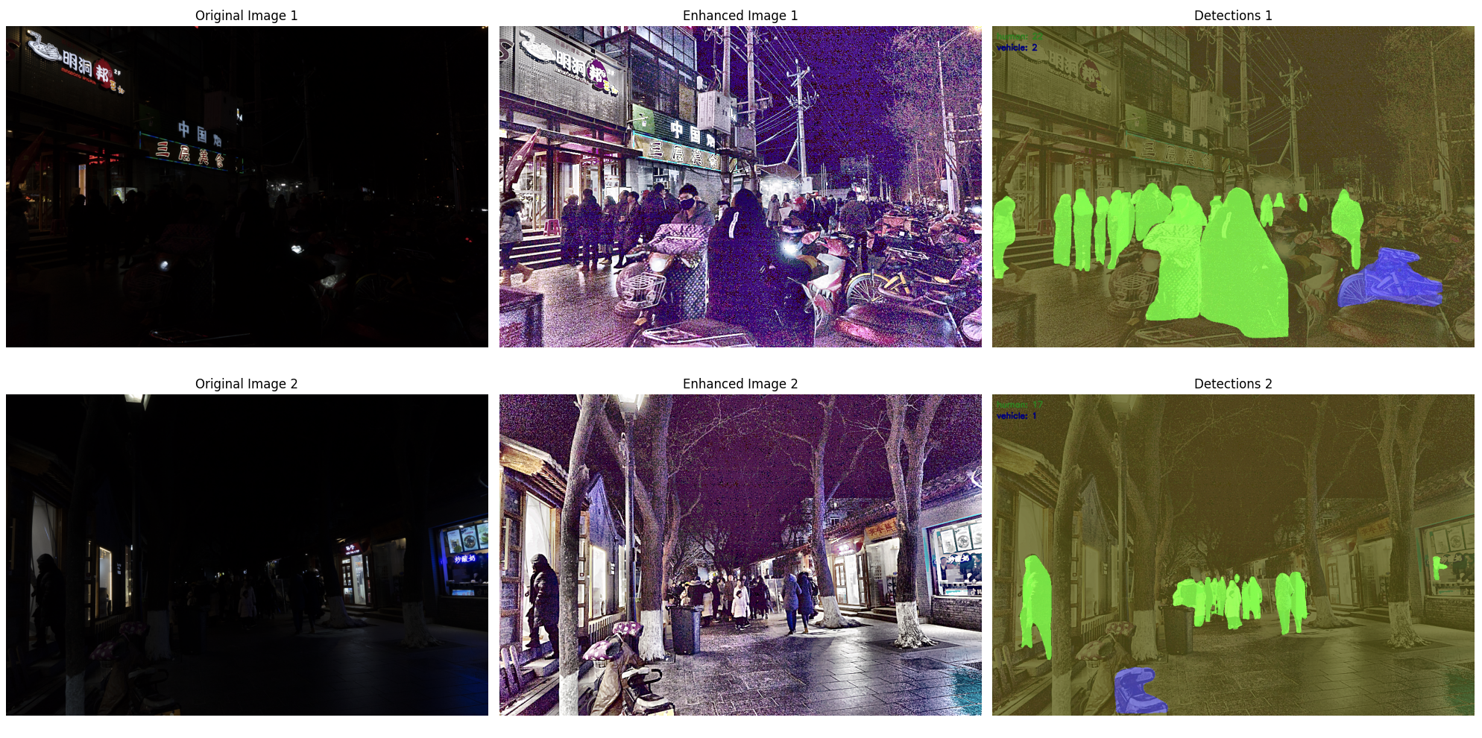

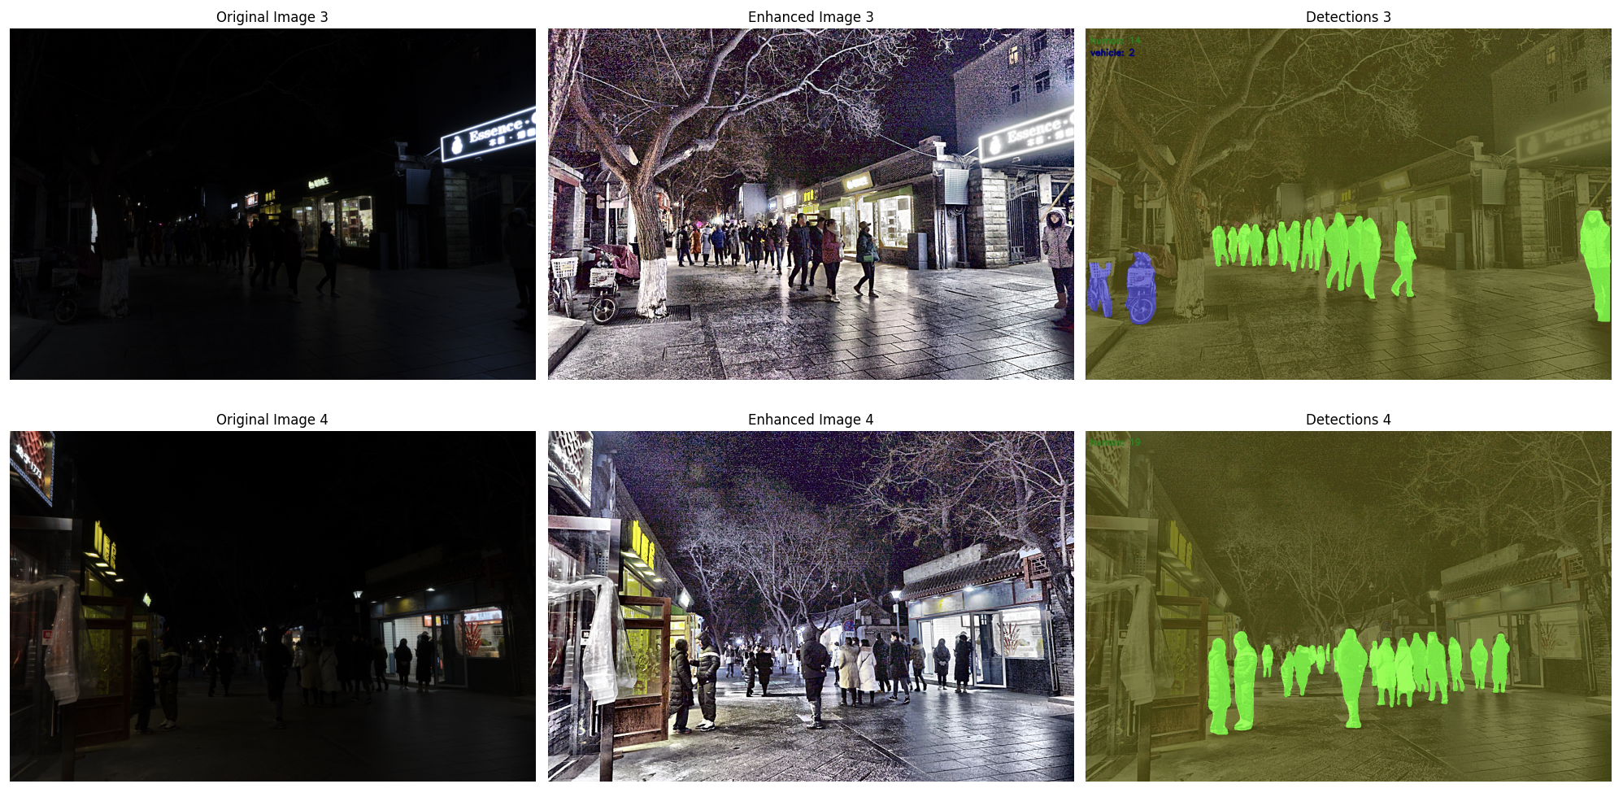

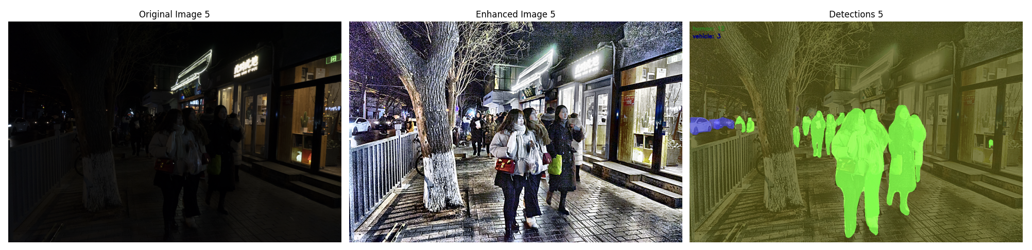

### Performance Metric Evaluation

The performance of the object detection model was evaluated using key metrics: **Precision**, **Recall**, **Average Precision (AP)**, and **Mean Average Precision (mAP)**. These metrics provide a comprehensive assessment of the model's ability to correctly identify and classify objects in the presence of varying levels of confidence.

* **Precision**: The precision of the model was calculated as 0.8333, indicating that approximately 83% of the predicted positive cases were true positives. This reflects the model's accuracy in predicting the correct classes without excessive false positives.
* **Recall**: The recall value was also 0.8333, meaning that around 83% of the true positive instances were correctly identified by the model. This shows that the model successfully detected most of the relevant objects, minimizing false negatives.
* **Average Precision (AP)**: The average precision (AP) was 0.7500, which quantifies the precision-recall trade-off for each class, taking into account various thresholds. This suggests that the model maintained a reasonably high level of precision across different recall values.
* **Mean Average Precision (mAP)**: The mean average precision (mAP) was calculated as 0.7500. mAP is the average of AP scores for all object categories, and this value reflects a good overall performance in terms of both detection and classification accuracy across all classes.

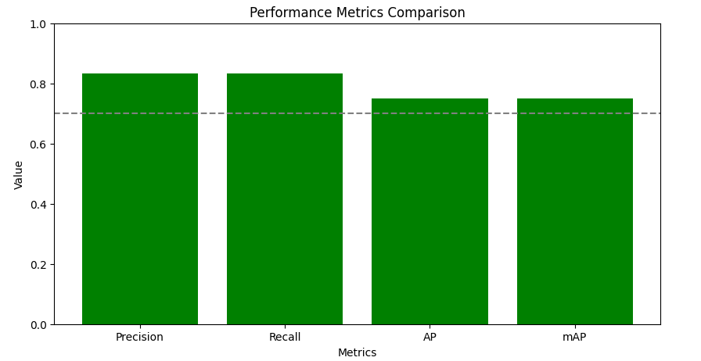

### Threshold Evaluation

* A performance threshold of 0.7 was set for each metric to determine whether the model meets the expected standards.
* All metrics—precision, recall, AP, and mAP—exceeded this threshold, demonstrating that the model performs well within the desired accuracy range for both object detection and classification tasks.

### Conclusion

In this work, the visual quality of the images was significantly enhanced through a series of advanced image enhancement techniques, including histogram equalization, CLAHE (Contrast Limited Adaptive Histogram Equalization), bilateral filtering, gamma correction, and unsharp masking. These methods improved the overall clarity, contrast, and detail of the images, making them more suitable for subsequent analysis.

For object detection, we employed semantic segmentation to identify and categorize various objects within the scene. Each object category was color-coded for easy identification: **humans** were highlighted in **green**, **vehicles** in **blue**, and the **background** in **yellow**. This color-coding enabled a clear distinction between different object types, enhancing the interpretability of the detection results. The integration of these techniques allows for more effective analysis, especially in challenging conditions such as low-light environments, ensuring that important features are accurately detected and represented.